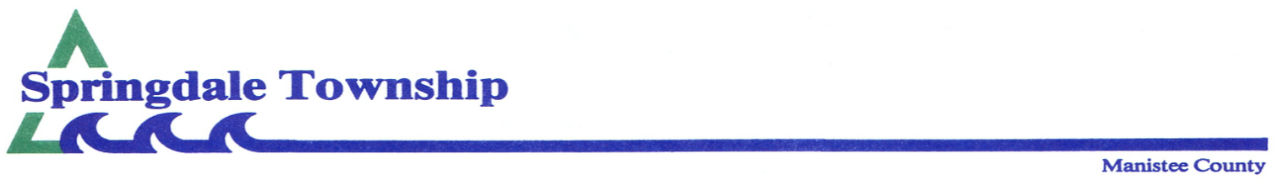 **Special Meeting Agenda**

**Monday, March 23, 2020 7:00 p.m.**

Meeting called to order at 7 p.m. by Supv. Brian Moore, followed by the Pledge of Allegiance.

**In attendance**: Brian Moore, Richard Hitchingham, Penny Nelson, Keith Moore, Judy Wheelock

Representing the Snowbirds was John Girven.

With no agenda additions or corrections, motion by B. Moore; 2nd P. Nelson to approve the agenda. Carried.

**Board discussion about Manistee-Benzie Snowbirds request.** Questions arose about the township’s financial obligation in conjunction with this grant. Agreed to have the township attorney and the representative of the Snowbirds work on that question. All board members agreed that with that done, the resolution to support was acceptable. Due to extenuating circumstances of the Covid-19 virus restrictions to public meetings, it was agreed to vote for this resolution by e-mail to the township clerk on Monday, March 30, 2020.



**Public comments**: No one from the public attended this meeting. It was advertised on our website and on the outside bulletin board.

**Board comments:** None.

**Adjournment** at 7:45 p.m.